**Advanced Software Engineering**

***Group Development Plan***

[Calum Henning, Duncan Austin, Katarina Alexander, Kate-Lynne Thomson & Stuart Paterson]

**Iterations**

1. Loading

Creation of these classes: Item, Order, ItemCollection, OrderCollection, FileInput, ItemLoader, OrderLoader, Manager (limited functionality), print to output.

Unit tests for each class will be created here as we will use test driven development in this iteration.

1. Report Generation

Add further functionality to Manager class by adding ability to output report and add items and orders. Extend OrderCollection and ItemCollection classes to include methods to get frequency etc.

1. GUI1

Creation of CafeGUI class, ability to add items to orders and add to OrdersCollection, view total price of order, generated report includes added items.

1. GUI2

Addition of discount item type, addition of DiscountCalculator class, method to find best discounts, ability to have multiple discounts combined.

1. Full system testing

Testing all system classes where appropriate and comparing to expected outcomes.

A picture containing screenshot

Description generated with very high confidence**Gantt Chart**

**Use Case Diagram**



A close up of text on a white background

Description generated with very high confidence**Activity Diagram**

A screenshot of a cell phone

Description generated with very high confidence**Sequence Diagram**

**Class Diagram**

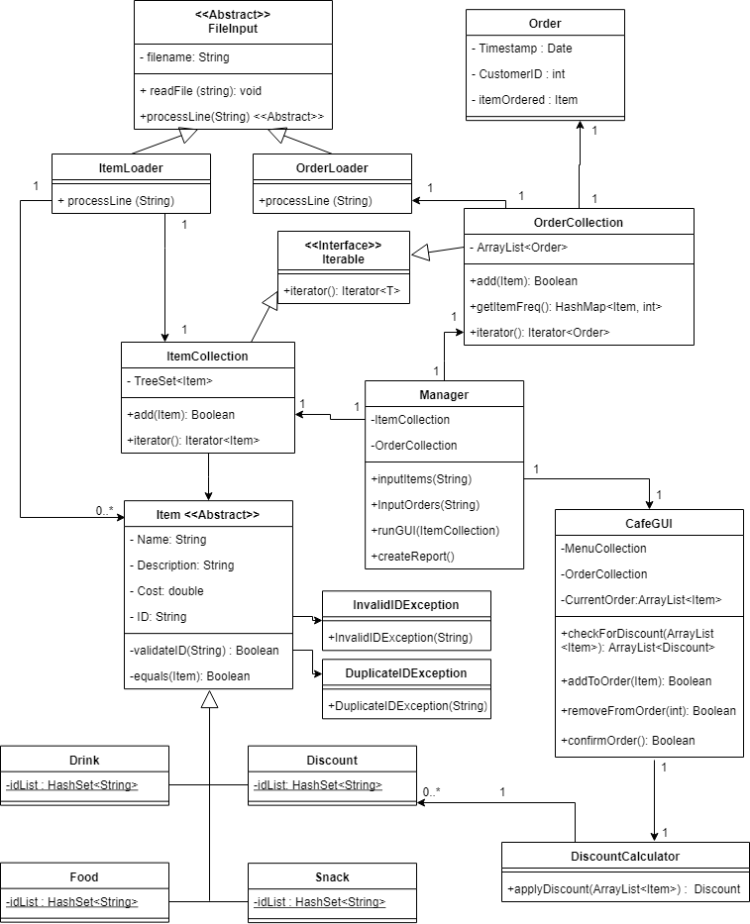

Standard Constructors and getters and setters have been omitted

**Chosen Collections**

OrderCollection = ArrayList

-> easy to add elements, kept in order of addition

ItemCollection = TreeSet

-> ordered, no duplicates

idList(Drink,Food,Snack) = HashSet

-> no duplicate ids allowed

CurrentOrder = ArrayList

-> easy to add items to order after selection